LAB 5
Q1
.data
array1 BYTE 10, 20, 30, 40, 50
.code
mov esi,0
mov ecx,lengthof array1
mov edi,sizeof array1
L1:
movzx eax,array1[esi]
push eax
add esi,type array1
loop L1
mov esi,0
mov ecx,lengthof array1
L2:
pop eax
mov array1[esi],al
add esi,type array1
loop L2
call DumpRegs
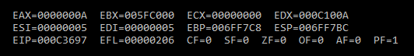
Q2
.code
main PROC
mov eax,1
call DumpRegs
mov ebx,0 ; initial setup
mov edx,1
mov ecx,9 ; count
L1:
mov eax,ebx ; eax = ebx + edx
add eax,edx
call DumpRegs ; display eax
mov ebx,edx
mov edx,eax
Loop L1
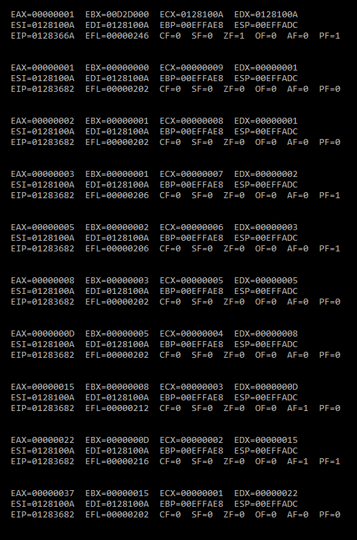

Q3

include irvine32.inc

.data
myArray BYTE 15, 10, 25, 20, 30
var byte ? ;used to swap
var1 dword 0 ; flag variable (to avoid error)
var2 sdword 1 ; flag variable (to avoid error)
.code
main PROC

; initialing registers
mov ebx,0
mov eax,0
mov esi,0

mov ecx,LENGTHOF myarray

l:
mov eax,ecx ;j
mov ebx,ecx ;i
dec eax ; j = i - 1
mov ecx , eax
;dec eax
cmp var2 ,ecx ; to aoid infinte loop when ecx = 0
jg m

l2:
mov dl , myarray[ebx* TYPE myarray - 1] ; value at [i]
mov var,dl
mov dl,myarray[eax* TYPE myarray - 1 ] ; value at [i-1]

cmp dl,var
jg l1 ;jump to swap
jmp x ; to avoid using swap algo
; SWAP
l1:
;dec ecx
mov myarray[ebx* TYPE myarray -1],dl
mov dl,var
mov myarray[eax* TYPE myarray - 1],dl
jmp x ; useless
x:

dec eax ; j = j - 1
loop l2
;cmp var1,ebx TO avoid error but seem useless
;jg m
mov ecx,ebx ; retrive i

loop l
m:

mov esi,0
mov ecx,5
mov dh,1
mov dl,0
print:

mov al,myarray[esi]
call writeint
call gotoxy
inc esi
inc dh
mov dl,0
LOOP print

exit
main ENDP
END main

